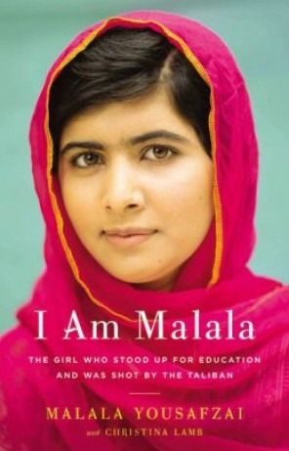
I AM Malala

Reading Response
You may either hand write or type your response for each chapter. Name and date should be listed on the upper write hand corner. If you had write please make sure your writing is legible.
Part 1
- Type/write chapter and title
- One sentence on the significance of the title
Part 2
- Respond to one of the questions from your list
- Answer must be five sentences long
Part 3
- Select a significant quote from the chapter and write it
- Why is it important in terms of literary quality?
- Minimum of two sentences in response to quote
- Reference literary terms when applicable

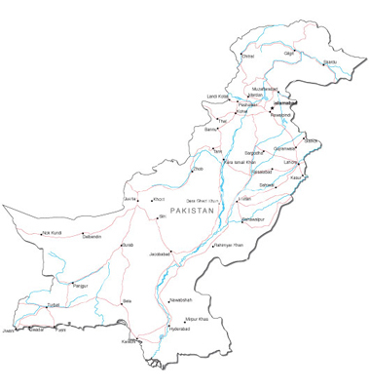
Part 2 questions to choose from:
What do you think about the progression of the text?
What interests you so far, or turns you off?
How do you feel about Malala?
Which events or actions are unclear to you? How so?
Why are you involved, or uninvolved in the reading?
What confuses, concerns, or angers you so far?
How is the story similar or different from experiences in your own life?
If I were (name of character) at this point, I would….

After getting part of the way through, what is happening?
What words, actions, or events are important?
Does the main character(s) react to important events as you would?
What bothers you, or confuses you?

How do you react to the ending?
Have the characters changed in any way?
Have you changed in any way?
What do you like most or least about this book?
What is the overall message or theme of the story?

