Romeo and Juliet Questions and Journal Work
Read Act One, Scene One
1. Put the following events in the correct order:
a. Romeo talks to Benvolio about his feelings of love for Rosaline.
b. Tybalt thinks that Benvolio is trying to start a fight with the Capulet servants.
c. Lord and Lady Montague notice that Romeo was missing from the fight.
d. Lord and Lady Montague and Lord and Lady Capulet enter the scene and see the fight.
e. Prince Escalus warns the two families not to fight again, or they will be punished.
Read Act One, Scenes Two and Three
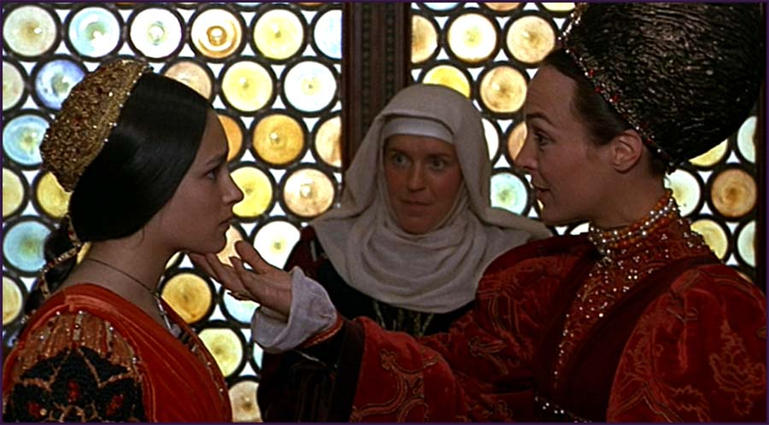
2. Do you remember what happened at the start of Romeo and Juliet? Prepare a summary of what happened in Act 1, Scene 1.
3. Look at the picture. Who are the three women? What are they are talking about?
4. Answer the questions.
a. How does Romeo find out about the party?
b. Why does he want to go there?
c. Why does Lady Capulet want Juliet to marry Paris?
d. Do you think Juliet wants to marry Paris? Why or why not?
5. What do you think will happen at the Capulet ball?
a. Will Romeo find love?
b. Will Paris persuade Juliet to marry him?
c. Will the Capulets and Montagues fight?
Read Act One, Scene Four 8.
6. Here are some parts from Act 1 Scene 4 of Shakespeare’s original playscript, written in the English that people spoke 500 years ago. Work in groups. Read these passages and look back over your playscripts. Who are these people talking to?
a. Tybalt: Uncle, this is a Montague, our foe, A villain that is hither come in spite
b. Capulet: And, to say truth, Verona brags of him To be a virtuous and well-govern'd youth: I would not for the wealth of all the town Here in my house do him disparagement
c. Nurse: Her mother is the lady of the house, And a good lady, and a wise and virtuous
d. Juliet: Go ask his name. — If he be married My grave is like to be my wedding bed
Translate the passages into modern English.
Read Act Two, Scenes One and Two
7. How do you think the second Act will finish?
Read Act Two, Scenes Three and Four
8. Put the following events from Acts One and Two into the correct order.
a. Romeo and Juliet are secretly married by Father Lawrence
b. Paris asks Lord Capulet for permission to marry Juliet
c. Romeo secretly meets Juliet and asks her to marry him
d. Romeo tells Juliet’s nurse of the wedding plans
e. The Capulets and Montagues are caught fighting by Prince Escalus
f. Romeo and Juliet discover which families they are from
g. Romeo and Juliet meet for the first time at the Capulet Ball
h. Lady Capulet tells Juliet of Paris’ desire to marry her
9. Imagine that you are about to marry the person of your dreams. Write the wedding vows which you will say at your wedding. OR Write a love letter from Romeo to Juliet OR Juliet to Romeo that will be delivered just before the wedding.
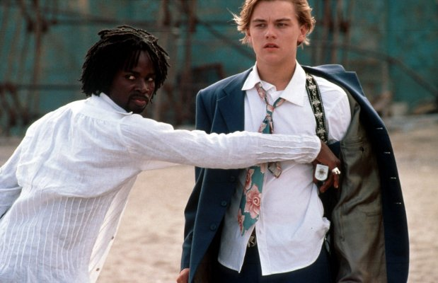
Read Act Three, Scenes One and Two
10. Look at the picture from the film. What is happening? What will happen next?
11. Answer the questions.
a. Why does Tybalt want to fight Romeo?
b. Why, at first, does Romeo refuse to fight Tybalt?
c. Why does he change his mind?
d. What is Romeo’s punishment?
12. Prince Escalus has to punish Romeo for killing Tybalt. Brainstorm ideas for and against executing Romeo. Decide which argument you support and write a brief letter to the Prince outlining your opinion.
Read Act Three, Scenes Three, Four and Five
13. Are these statements true or false? If false, write a correct statement.
a. Father Lawrence tells Romeo to stay in Verona.
b. Romeo can spend one more night with Juliet.
c. Juliet’s parents want her to marry Romeo.
d. Juliet refuses to marry Paris.
14. Imagine that Lord and Lady Capulet discover Romeo and Juliet together. ‐ What would they say? ‐ What would they do? Write an alternative Act 3, Scene 5 based on your ideas. (We will perform this scene to the class)
15. What do you think Juliet will do next?
Read Act Four, Scenes One and Two
16. Look at your predictions from Exercise 23. Were you correct?
17. Answer these questions.
a. What is Father Lawrence’s advice to Paris?
b. What is Father Lawrence’s plan for Juliet?
18. Work in pairs. Imagine you are Lord and Lady Capulet. You are planning the wedding of your daughter. The wedding is tomorrow. Write a list of 10 things to do before the wedding.
Read Act Four, Scenes Three and Four
19. Read the following sentences. They tell Romeo’s story. Decide if each is true or false. If false, write a correct statement.
a. Romeo often fought with members of the Capulet household
b. Romeo was in love with Rosaline
c. Romeo went to the Capulet party to meet Juliet
d. Romeo and Juliet’s families are enemies
e. Father Lawrence secretly married Romeo to Juliet
f. Romeo killed Tybalt in revenge for Benvolio’s death
g. Romeo must wait in Venice until Father Lawrence sends a message
The following sentences tell Juliet’s story. Decide if each is true or false. If false, write a correct statement.
h. Juliet is Tybalt’s sister
i. Juliet wanted to marry Paris
j. Juliet is thirteen years old
k. Juliet first met Romeo in the street after the two families fight
l. Juliet sends her nurse to make arrangements with Romeo for the wedding
m. Juliet asks Father Lawrence to help her avoid marrying Paris
n. Juliet decides to marry Paris and forget Romeo
o. Juliet kills herself to avoid marrying Paris
28. What do you think will happen next?
a. Will Romeo return to Verona?
b. Will Romeo and Juliet live happily together?
c. Will the Capulets and Montagues stop fighting each other?
Read Act Five, Scenes One and Two
29. Look at your predictions from Exercise 28. Were you correct?
30. It is a serious crime to sell poison which will be used to kill someone. If you were the shopkeeper, would you have sold Romeo the poison? Write your arguments for or against selling Romeo the poison.

